APPLICATION FORM 2022
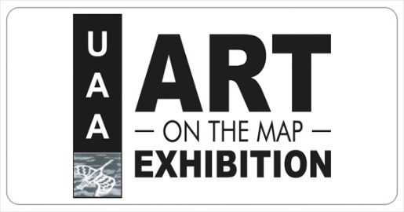
Uist and Barra Artists Studio Trail, and Exhibitions

Return FINAL Deadline: FRIDAY 1st April for inclusion in printed brochure.
Events can continue to be added to the online information on the website, but they will not be in the printed brochure.
Further details are available on the UAA website at uistarts.org/aotmabout
Please email your completed forms and image to uistarts@gmail.com
This year we are offering a simplified Art on the Map
A simplified flyer that identifies artists and studios open with two categories
- Venues with standard opening hours all summer
- Venues that are open by appointment, and where specific opening hrs can be updated to the website nearer the time.
We are aiming to have the brochures printed and ready for distribution by the end of May Bank holiday, along with some other trail maps being prepared by Taigh Chearsabhagh for some of their activities.
Our Open Summer exhibition will be held in Taigh Chearsabhagh from 2nd July – 6th August and as last year we have agreed with TC to have a paid gallery assistant who will also act as a point of contact for visitors to signpost and help encourage studio visits, and generally be on hand to provide information about our members and their work.

Art on the Map 2022 Fee Summary
Individuals | £20 for UAA members – this is a one-off fee and can cover more that one entry for each individual and can be purchased here  https://uistarts.org/shop/individuals-art-on-the-map-2022/  UAA membership is £15 p.a and can be purchased here uistarts.org/join

Details for registration purposes
Name
Email
Phone
Address | For those who prefer not to use email and electronic registration only

Payment
I confirm that I have paid the event fees (£20) on line on the UAA website uistarts.org/aotmabout
or
I have sent cheque, made payable to Uist Arts Association to Peter Ferguson, UAA Treasurer, 15 Balemore, North Uist, HS6 5EB

Details of your event
Note: you may have more than one, please repeat for each event as necessary.
All of this information will be printed on the brochure
Artists Name
Name of venue/studio/event
Address of event/studio including postcode

Phone number
Email address
Website
Social Media
Disabled Access
Image included

It is also useful to know if you can take card payments or if people need to bring cash, or sort out bank transfers.
Can take card payments | Yes/No

A brief description of your work or event – NO MORE THAN 20 WORDS – eg: “landscape paintings depicting the colour and light of the islands “
You will have an opportunity to add a fuller description yourself on your website entry if you wish

Dates and Times of opening
Delete as applicable
Open by appointment only

Regular opening hrs
List your hours here

Image
A high-resolution jpeg image of your work to be used for your listing in the brochure and on the website Min 300dpi resolution - please save with your name as part of the file name. If your image is not square it will be cropped to suit the layout of the brochure.

Signs:
Art on the Map signs will be provided for display outside your venue. Signs are 31x62 cm and double sided. Please note that there will not be a charge for the signs, provided they are returned without damage just after the 2022 trail. Each sign is worth £20. Please Indicate if you would like a sign and how many you require.
Please indicate if you already have signs squirrelled away in your shed or attic.
We will start with an allowance of 2 signs per venue, but may be able to stretch to more once we have an indication of how many we need and have.

Insurance:
As a condition of being part of Art on the Map all venues, open studios, halls, public buildings must have public liability insurance (PLI) cover, and as responsible organisers we need to be sure that people have this in place for their event.
As part of submitting this application you are confirming that you will take out insurance as necessary to cover your event for the duration of your openings for Art on the Map 2022, and if you are in a public building will check with the building that you are exhibiting in that you are covered under their Public Liability Insurance, or take out your own. You will also need to undertake a formal risk assessment

I confirm that I will have PLI in place and will undertake a risk assessment

There is more information on the UAA website about recommended sources of insurance for artists who wish to open their studios or cover their exhibitions. See uistarts.org/aotmabout

Completion:
Please email your completed forms and image to uistarts@gmail.com
The information in your form will also be used to set up a basic Art on the Map website profile for you and/or your event. You will be sent login details to edit the information directly.

FINALLY – but by no means least
If you are able to help with the collation of info, organisation and distribution of flyers please let us know.

